**Ref. No. MES IMCC /** 172**/ 2025 – 26/ Date:** 21/11/2025

**CERTIFICATE**

This is to certify that the Project entitled **“Daily Meal Planning and Subscription Web Application** “is completed by **“Mrudul J. Kuchankar**” of S.Y. M.C.A. Semester III for the Academic Year 2025-26 at MES’ Institute of Management & Career Courses (IMCC), Pune - 411038.

To the best of our knowledge, this is an original study done by the said student and important sources used by him/her have been duly acknowledged in this report.

The report is submitted as a part of course ITP31 Mini Project for the Academic Year 2025-26 as per the rules and guidelines prescribed by the institute.

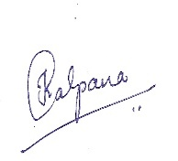 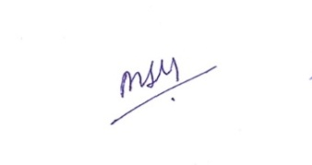 

Ms. Kalpana Dhende Ms. Manasi Shirurkar Dr. Ravikant Zirmite

Project Coordinator Program Coordinator Head, Dept. Of MCA

**Daily Meal Planning and Subscription Web Application**

This is a dynamic web-based platform that connects users with local tiffin provider for a specific area. It simplifies for people to subscribe to healthy home-style meals. Customers can choose different **meal plan**, select their **meal type** and also decide between **veg and non-veg** options.

**Users of the System:**

1. **Customers (End Users):**

Customers are the end-users who subscribe to the tiffin service. They can register and log in to the system, select suitable meal plans based on their preferences, choose food type (vegetarian or non-vegetarian), and specify whether they want lunch, dinner, or both. Customers also have the flexibility to skip meals on certain days, order extra tiffin whenever required, or cancel their subscriptions, and track activities.

1. **Admin (Service Provider):**

The admin is the primary controller of the entire tiffin service system. The admin can view and manage all registered users, maintain meal plans and pricing, track customer subscriptions (active, upcoming, completed, or cancelled), and monitor requests such as skipped meals and extra orders. The admin is also responsible for handling payments, refunds, and ensuring smooth operation of the service.

1. **Guest (Unregistered Visitor):**

Anyone visiting the website without creating an account. Their access is limited to general information about the service.

**Modules**

**Admin Module:**

* Create/manage meal plans (Trial, Weekly, Monthly, Quarterly)
* Approve or monitor user subscriptions
* View skipped/extra tiffin requests from users
* Manage pricing for meal
* Update daily meal for Lunch and Dinner
* Refund amount to the skipped meals requests

**User Module:**

* Register/login to the platform
* Choose a subscription.
* View meal plan details and cost
* Make payments
* Order extra tiffin for any day
* Request to skip a tiffin before cutoff time
* Can view plan summary

**Subscription Management Module:**

* Users can choose from available meal plans (Daily, Weekly, Monthly, Quarterly).
* Automatically calculates the end date of the subscription based on the selected plan type.
* Allows selection of lunch, dinner, or both; and veg or non-veg food type.
* Dynamically tracks the subscription status as upcoming, active, completed, or cancelled.

**Payment Module (Dummy Payment):**

* Simulates the payment process for user subscriptions.
* Displays the subscription amount and allows users to “pay” for a plan.

**Technology Stack:**

Frontend: HTML, CSS, JavaScript, Bootstrap

Backend: Flask (Python)

Database: MySQL

**Database Tables:**

1. **Users**

|  |  |  |
| --- | --- | --- |
| **Field Name** | **Data Type** | **Description** |
| user_id (PK) | int (Auto Increment) | Unique User ID |
| name | varchar | Full Name |
| email | varchar (Unique) | User email |
| password | varchar | Hashed Password |
| phone | varchar | Contact Number |
| address | varchar | Delivery address |

1. **Meal Plan**

|  |  |  |
| --- | --- | --- |
| **Field Name** | **Data Type** | **Description** |
| plan_id (PK) | int Primary Key | Plan ID |
| plan_type | varchar | Trial, Weekly, Monthly, Quaterly |
| days | int | Number of days (3, 7, 30, 90) |
| veg price | decimal | Price of Veg meal |
| non-veg price | decimal | Price of non-veg meal |
| description | text | Description |

1. **User Subscriptions**

|  |  |  |
| --- | --- | --- |
| **Field Name** | **Data Type** | **Description** |
| subscription_id (PK) | int (Auto Increment) | Subscription ID |
| user_id | int | Foreign Key |
| plan_type | varchar | Trial, Weekly, Monthly, Quartely |
| start_date | date | Start date of Plan |
| end_date | date | End date of Plan |
| meal_type | enum (‘Lunch’, ‘Dinner’, ‘Both’) | Selection of meal time |
| food_type | enum('veg','nonveg') | Selection of Veg & Non-veg type |
| amount_paid | Decimal (8,2) | Total amount paid of subscribed plan |
| subscription_date | timestamp | Subscribed Date |
| status | enum('upcoming','active','completed','cancelled') | Status |

1. **Daily Meal**

|  |  |  |
| --- | --- | --- |
| **Field Name** | **Data Type** | **Description** |
| meal_id | int | Meal ID |
| meal_date | date | Date of meal |
| meal_type | enum('Lunch','Dinner') | Lunch, Dinner |
| meal_name | varchar | Food items name |
| meal_image | varchar | Image |
| lunch_nonveg_name | varchar | Non-veg meal for lunch |
| lunch_nonveg_image | varchar | Non-veg meal image |
| dinner_nonveg_name | varchar | Non-veg meal for dinner |
| dinner_nonveg_image | varchar | Non-veg meal image |

1. **Skipped Meals**

|  |  |  |
| --- | --- | --- |
| **Field Name** | **Data Type** | **Description** |
| skip_id | int (Primary Key) | Skipped Meal ID |
| user_id | int | User ID |
| subscription_id | int | Subscribed Id |
| skip_date | date | Date of skipped meal |
| meal_time | enum('lunch','dinner','both') | Meal Time |
| refund_amount | decimal (10,2) | Refund amount |
| refund_status | varchar(50) | Refund status |
| created_at | timestamp | Created Timestamp |

1. **Extra Tiffins**

|  |  |  |
| --- | --- | --- |
| **Field Name** | **Data Type** | **Description** |
| extra_id | int Primary Key | Extra meal ID |
| subscription_id | int | Subscribed ID |
| extra_date | date | Date of ordered meal |
| meal_type | enum('veg','nonveg') | Veg, Non-veg |
| quantity | int | Number of extra the meal ordered |
| total_amount | decimal | Total amount |
| status | varchar |  |
| created_at | timestamp | Created Timestamp |
| meal_time | enum('lunch','dinner') | Meal time of extra meal |

**ER Diagram:**

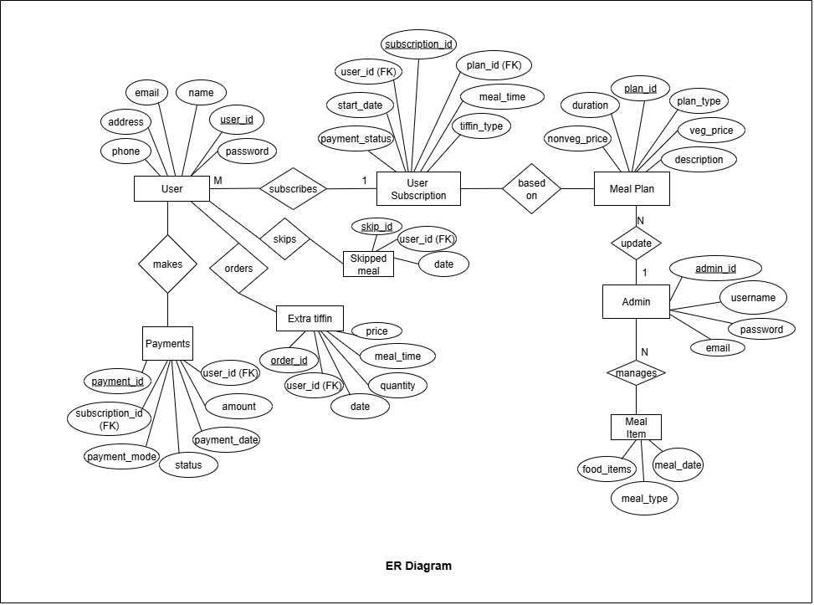

**Usecase Diagram:**

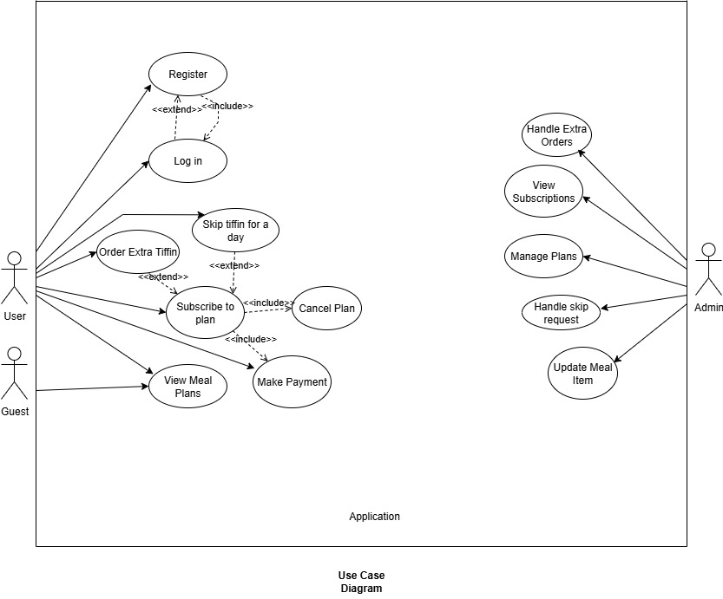

**Working Demo**

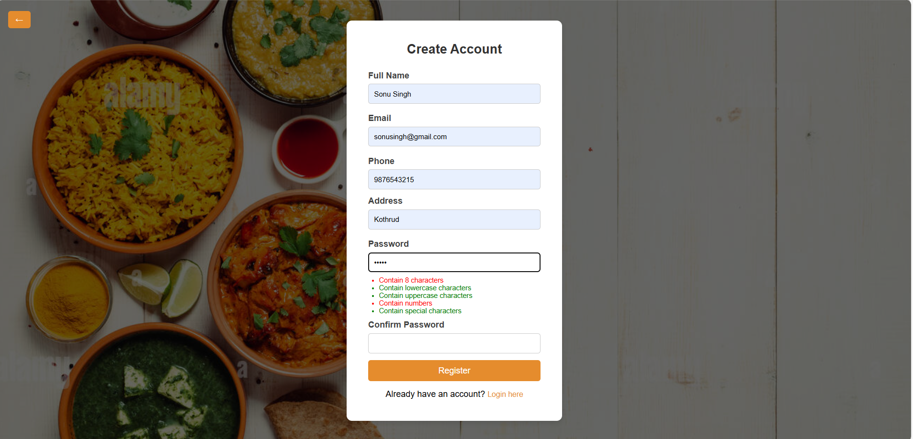

1. **User Registration Page**

* This shows the Create Account form with input fields, live password validation hints, and the registration button.
* The **Register** button becomes functional only after all validations are met.

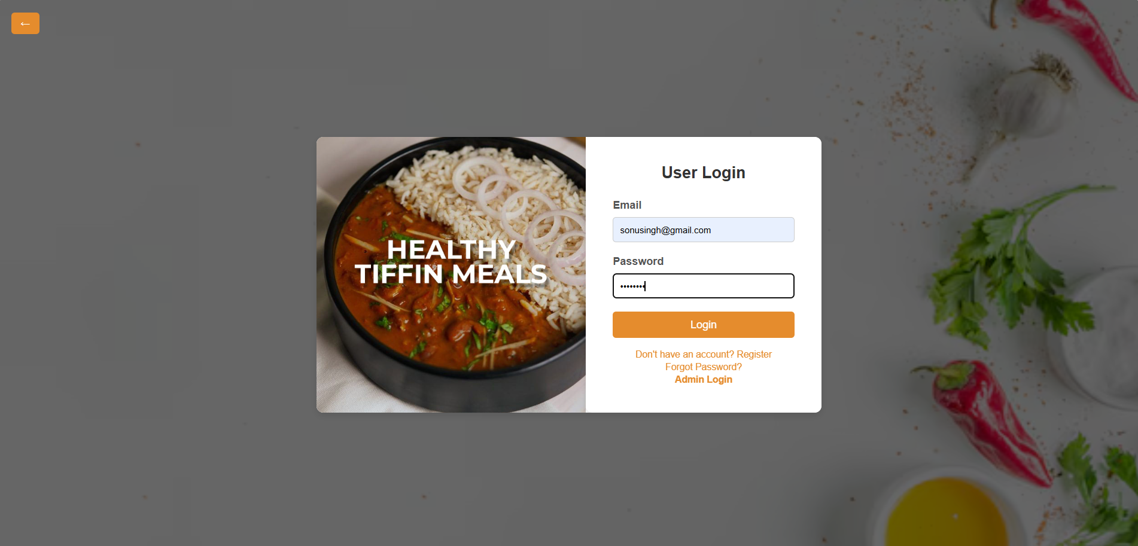

1. **User Login Page**

* The screenshot shows the **User Login Page**, where users enter their registered email and password to access the system.
* It provides quick links for **Register**, **Forgot Password**, and **Admin Login**, ensuring smooth navigation for all user types.

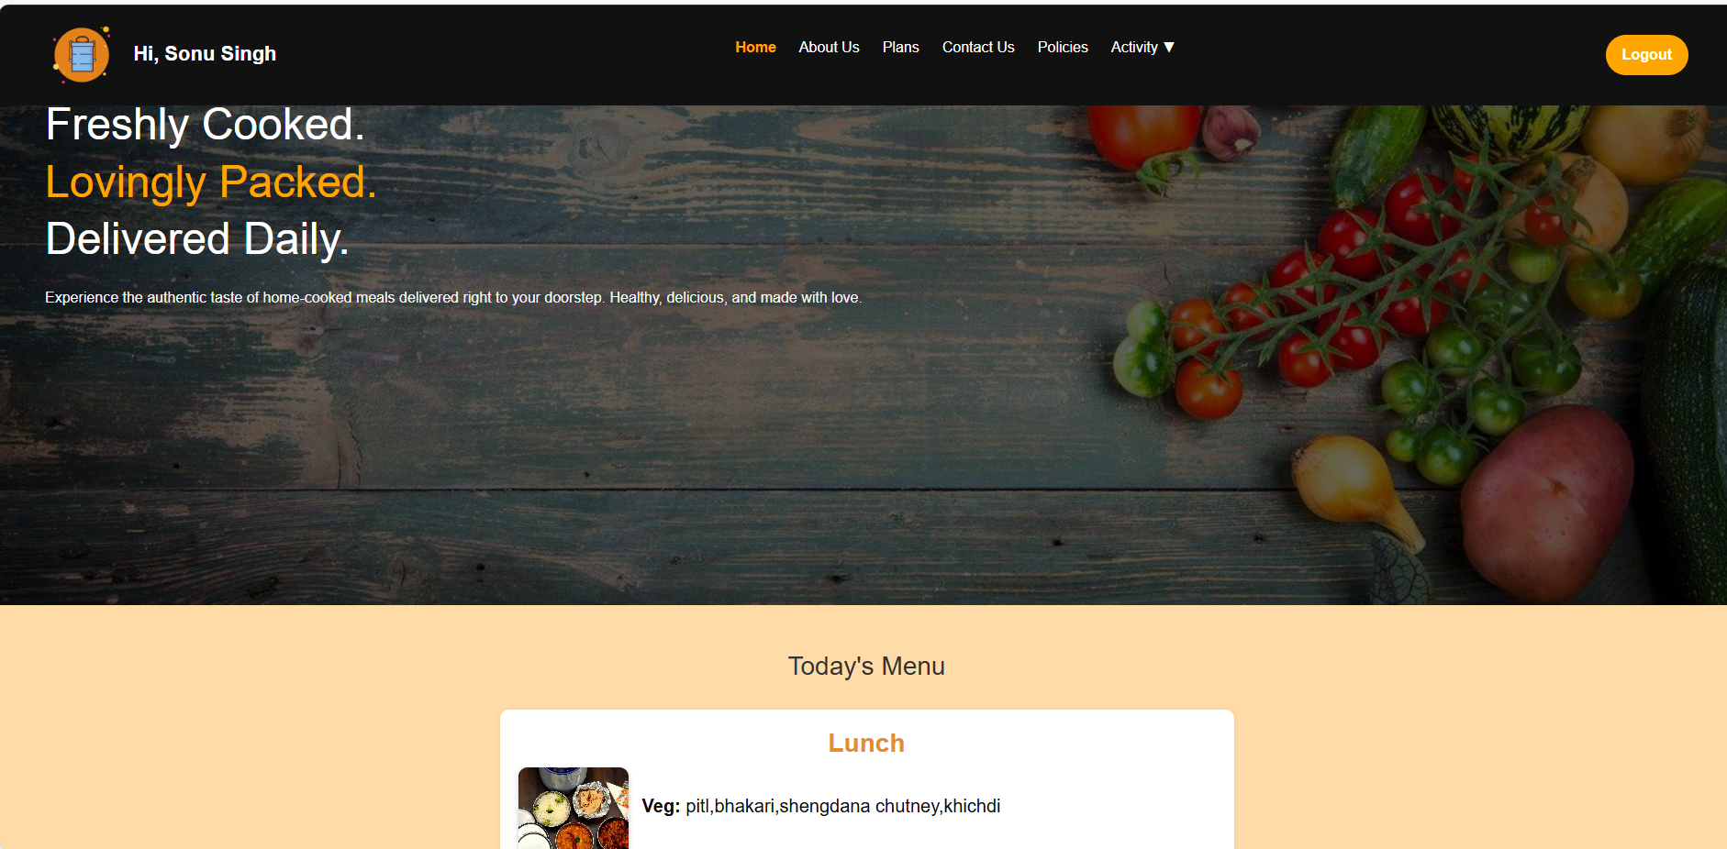

1. **User Dashboard**

* This screen displays the **User Dashboard**, showing a welcome message, navigation menu, and the daily tiffin menu for the user.
* It provides quick access to key sections like **Plans, Contact Us, Policies, and Activity**, along with a logout option for secure session handling.

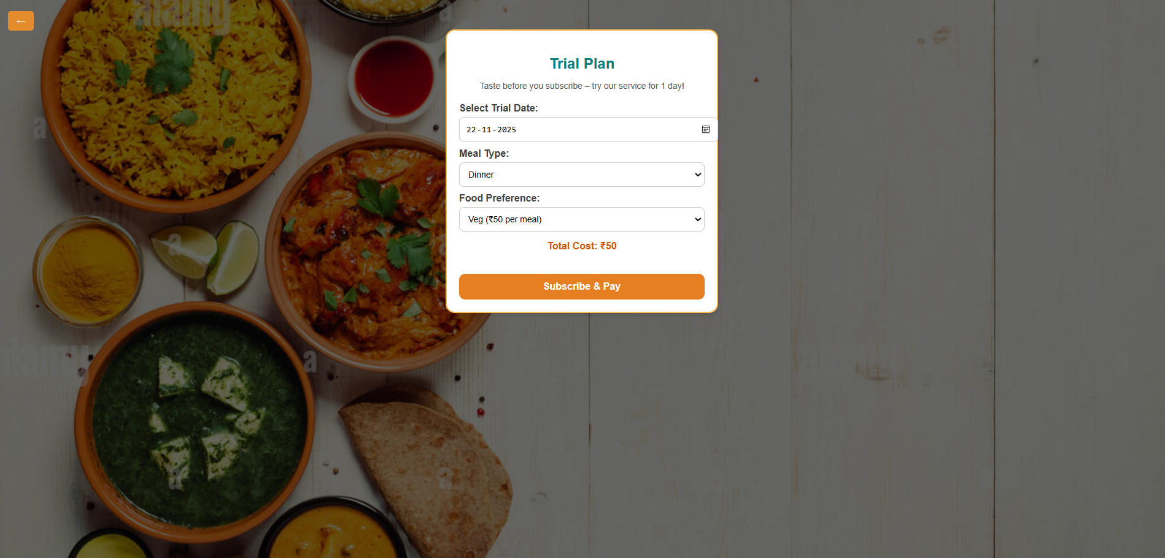

1. **Trial Plan Subscription Page**

* This screen displays the **Trial Plan Page**, where users can select a date, choose meal type and food preference, and view the total cost for a 1-day trial service.
* It allows users to proceed with the subscription using the **Subscribe & Pay** button, offering a simple and clear trial booking process.

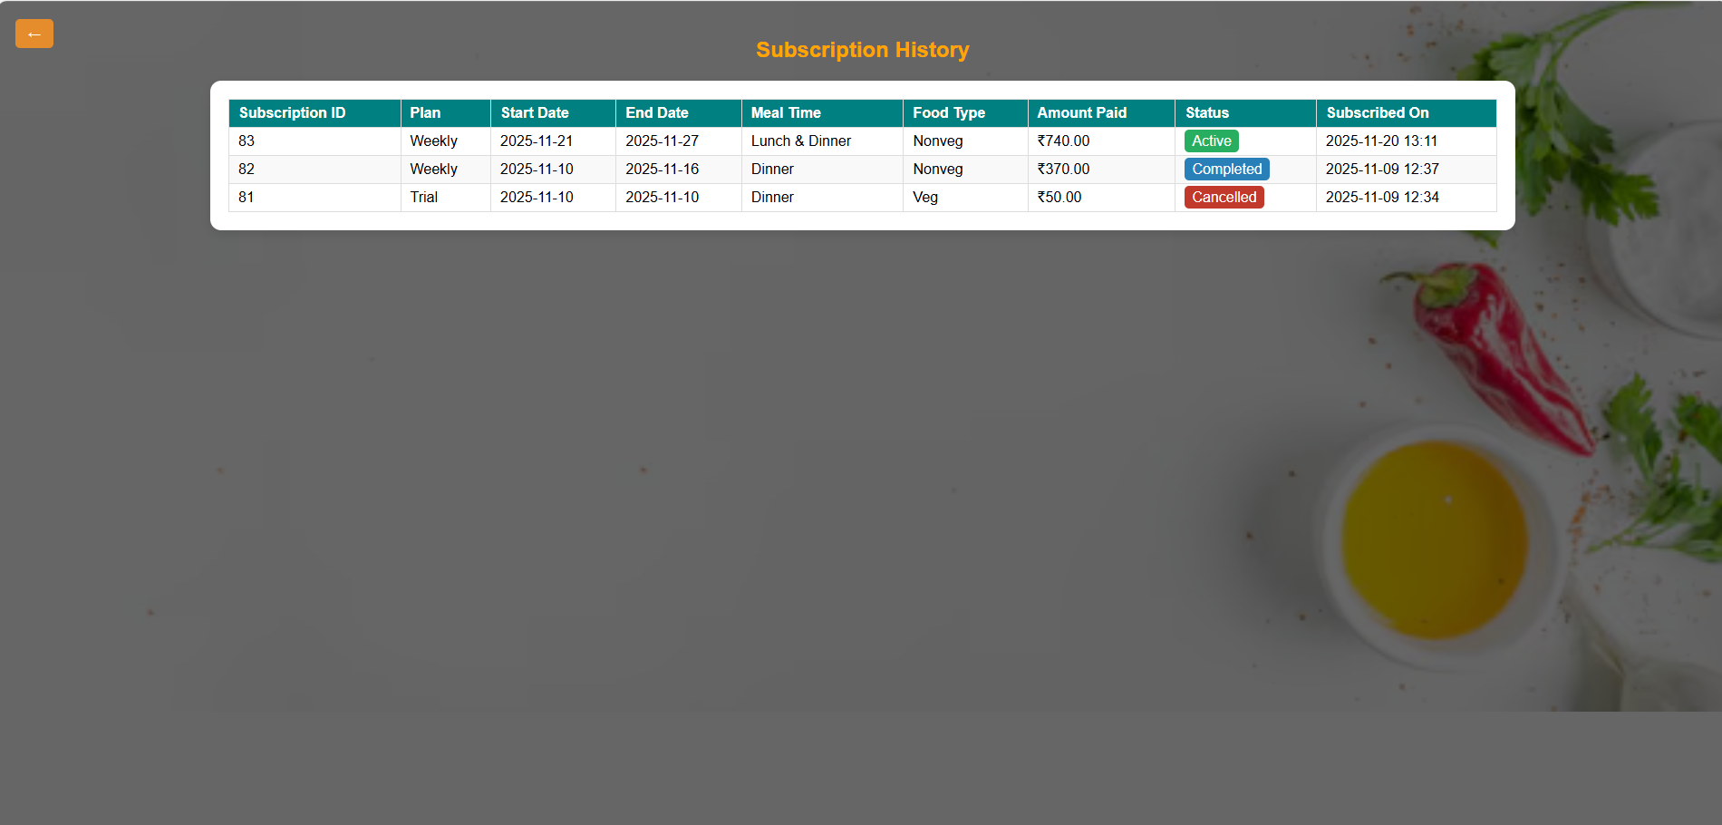

1. **Subscription History Page**

* This screen displays the **Subscription History**, showing all past and current plans with details like plan type, dates, amount paid, food type, and status (Active, Completed, Cancelled).
* It helps users easily track their previous subscriptions and stay updated on their current plan status.

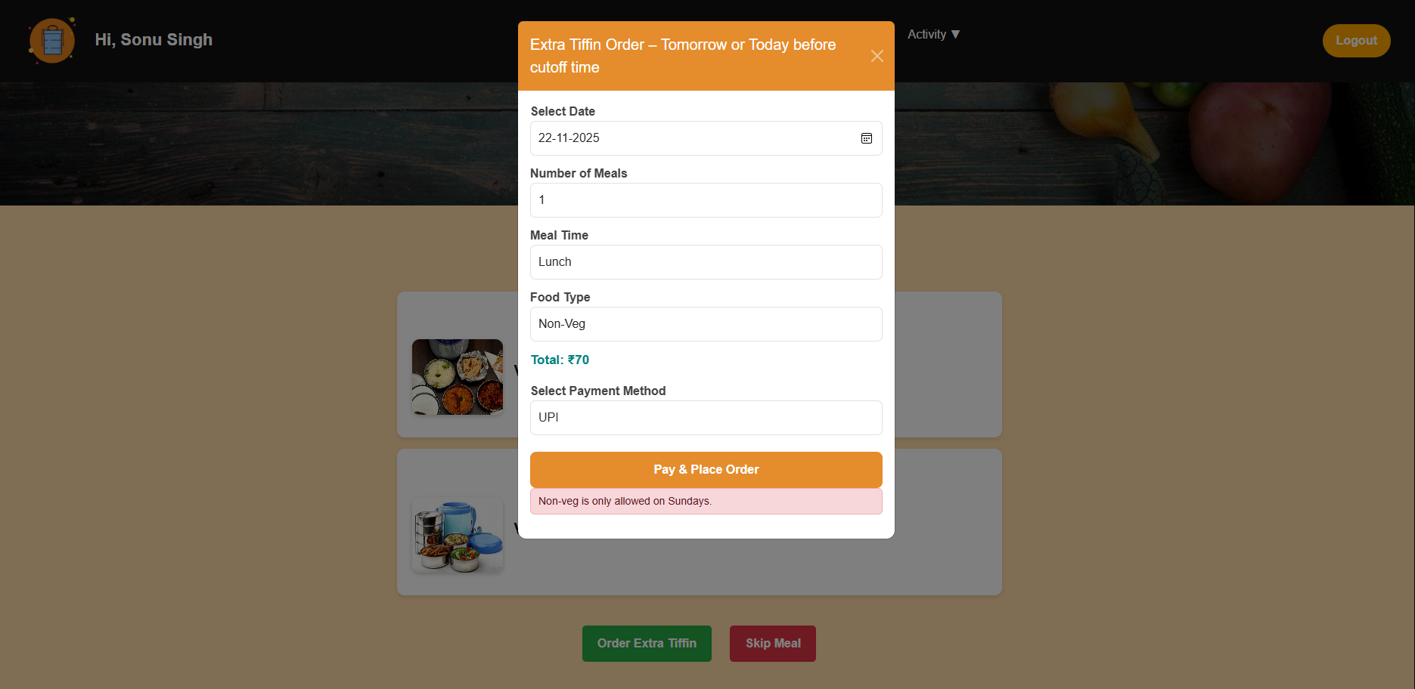

1. **Extra Tiffin Order Page**

* This screen shows the **Extra Tiffin Order popup**, where users can choose date, number of meals, meal time, food type, and payment method before placing an additional tiffin order.
* It also displays the **calculated total cost** and shows alerts such as restrictions (e.g., non-veg allowed only on Sundays) to guide user choices.

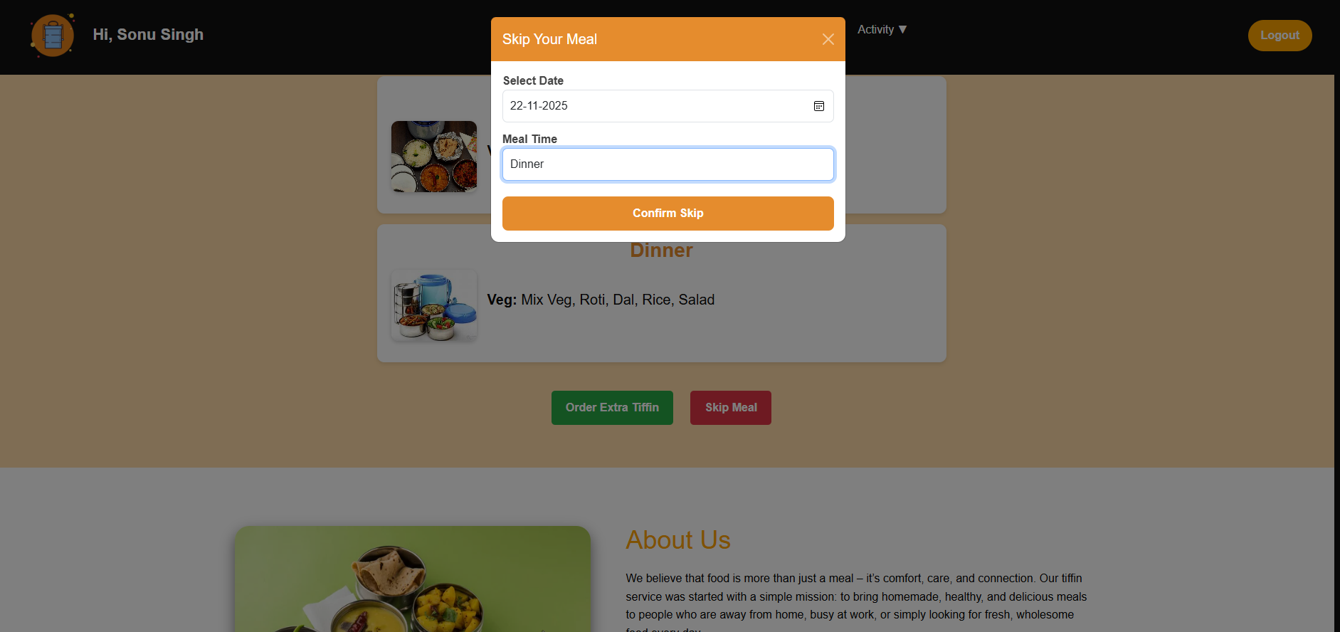

**7.Skip Meal Page**

* This screen shows the **Skip Meal popup**, where users can select a date and meal time to skip their tiffin for a particular day.
* It helps users manage their subscription flexibly by allowing them to confirm a meal skip with a single click.

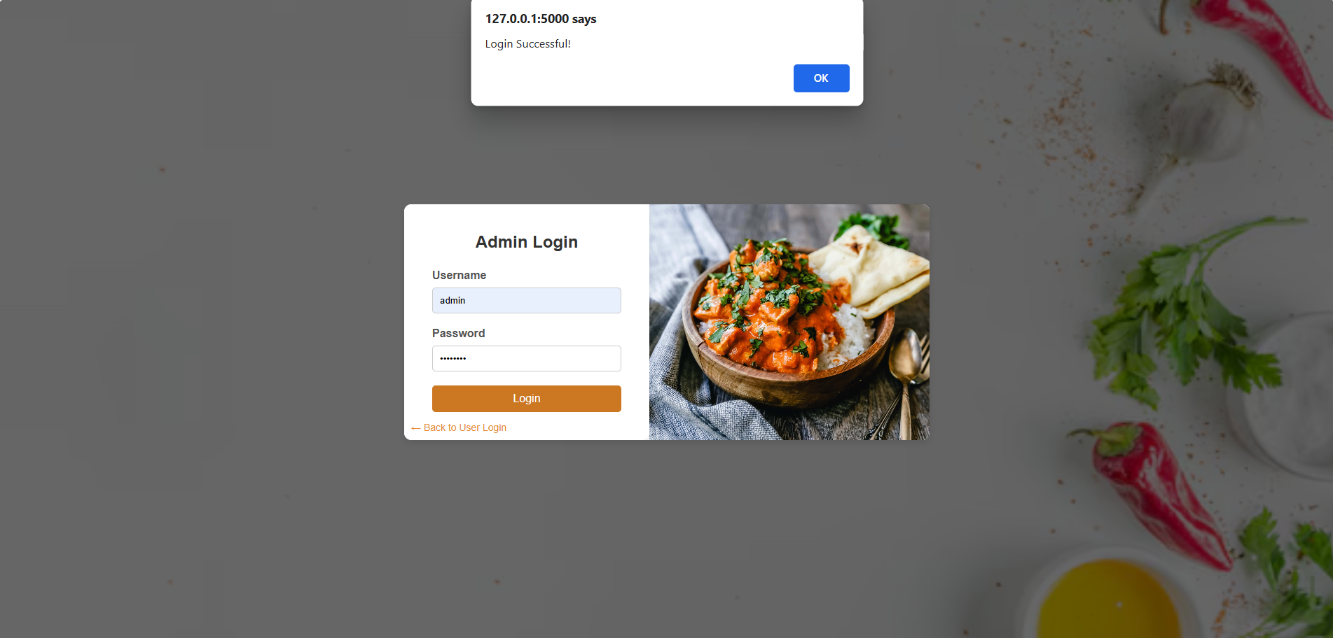

**8.Admin Login Page**

* This screen shows the **Admin Login Page**, where the administrator enters a username and password to access the admin dashboard.
* It ensures secure restricted access and provides a link to switch back to the user login page.

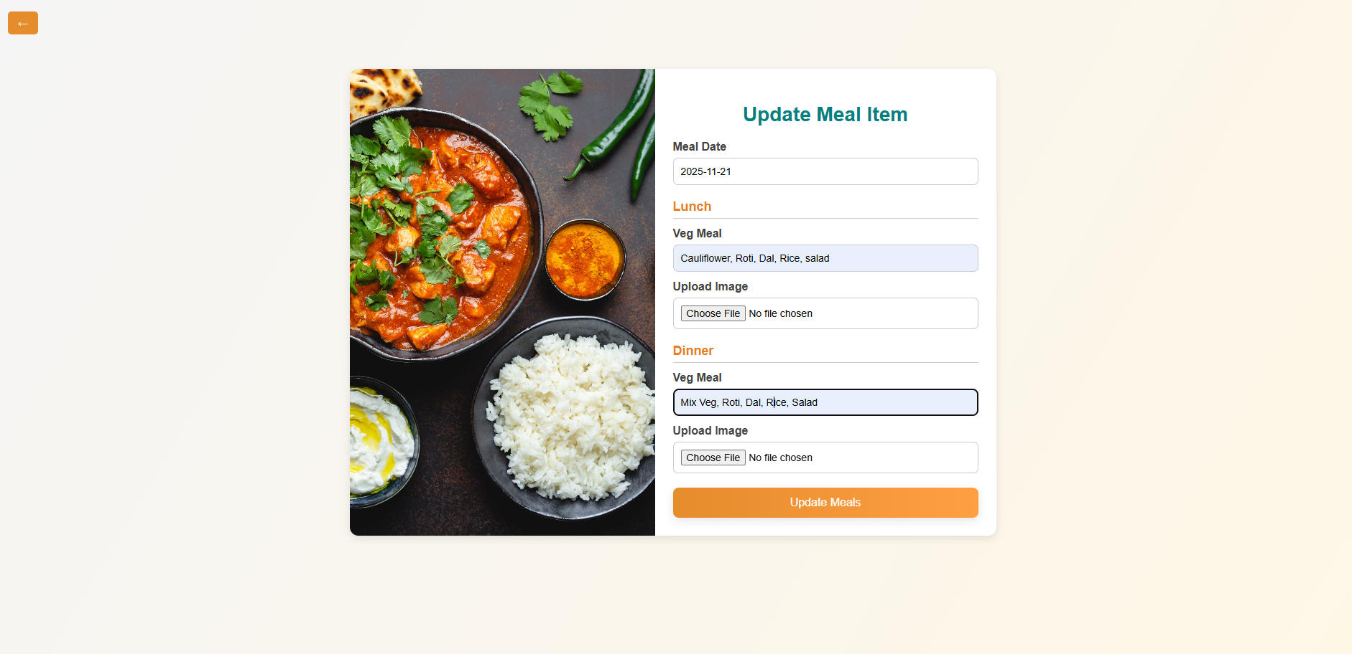

**9.Admin – Update Meal Item Page**

* This screen shows the **Update Meal Item Page**, where the admin can update lunch and dinner menus by entering meal details, selecting a date, and uploading images.
* It helps administrators manage daily meal updates efficiently to ensure users always see the latest menu.

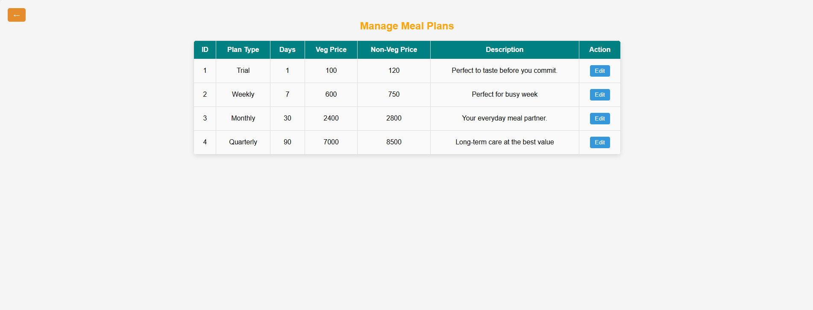

**10. Manage Meal Plans Page**

* This screen displays the **Manage Meal Plans Page**, where the admin can view all available plans along with their duration, prices, and descriptions.
* The page provides an **Edit** option for each plan, allowing the admin to update pricing or details whenever needed.